User manual

Table of Contents

Introduction 1

System Requirements 3

Installation 4

Layout 4

Use 4

Features 4

Errors 4

# Introduction

This tool simulates how ant’s characteristics affect behaviour and effectiveness of survival. It models three types of ants:

* **Worker ants** – Responsible for finding, collecting and depositing food to the nest.
* **Soldier ants** – Responsible for guarding ants of the same species and also attacking ants and nests from other species.
* **Queen ants** – Responsible for locating a site to create a nest, and then creating a nest.

**C:\Dropbox\projects\Ant-Simulation\assests\User Manual\Ants\Queen ant.PNGC:\Dropbox\projects\Ant-Simulation\assests\User Manual\Ants\Soldier ant.PNGC:\Dropbox\projects\Ant-Simulation\assests\User Manual\Ants\Worker ant (food).PNGC:\Dropbox\projects\Ant-Simulation\assests\User Manual\Ants\Worker ant (no food).PNG***From left to right – A worker ant, a worker ant carrying food, a soldier ant and a queen ant*

The simulation revolves around the ants struggle for food. Food is represented by green blobs. Food is slowly taken away from its original position by worker ants and deposited to the nest. The food is used for creating more ants as well as maintaining the current ants. The darker the colour of the food the more food is concentrated.

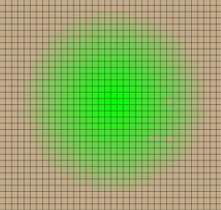

A blob of food

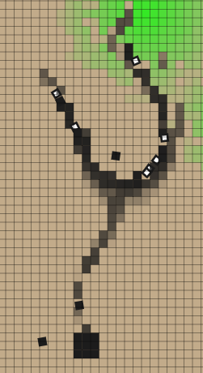

A pheromone trial from food to the nest. It is being followed by a number of ants so returning with food and others looking for food.

Ant nests are the birth place of all ants. If a nest has excess food i.e. more than enough for it to survive itself, a new ant can be born. The amount of food an ant costs is controlled by the ant’s species. The more food the ant costs, the longer it can survive for after it is born. Ants born from a particular nest remain loyal to that nest e.g. a worker born from a particular nest will only deposit food to that nest.

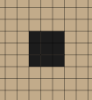

An ant nest

Pheromones are chemical trials deposited by worker ants returning with food back to the nest. They are used by ants who are looking for food, as they should lead to either a source of food or the nest. The stronger a pheromone trial is (the darker its colour) the more likely an ant will follow it. Over time the pheromones concentration will decrease as they evaporate.

Characteristics are features of ants which change their behaviour e.g. the speed characteristic alters how fast an ant can move in the simulation, this is an advantage as it allows the ant to more quickly search for food. However favourable characteristics come at a cost, the more useful a characteristic is the more food is lost in the creation of the ant. So a balance is required to find the most efficient or largest growing population of ants. The characteristics which can be changed are:

* **Speed** - The speed that an ant can move.
* **Jaw Strength** – The strength of the ants jaw (determines how much food the ant can carry).
* **Jaw Size** – The amount of damage a soldier ant can inflict.
* **Sting Size** – The range which a soldier ant can attack.
* **Eyesight –** The range an ant can see.
* **Eye Angle –** The angle through which the ant can see.
* **Antenna Size –** The angle through which an ant can detect pheromones.
* **Pheromone Concentration –** The concentration of pheromones an ant can secrete.
* **Nest Position Memory –** A measure of how well an ant knows where its nest is.
* **Explorative Influence** – The likelihood of an ant changing its direction e.g. not following pheromones.
* **Pheromone Influence** – The likelihood of an ant following a pheromone trial.
* **Worker ant probability** – The probability of a worker ant being born compared with other types of ants.
* **Worker ant food cost** – The amount of food required to create a worker ant (the more health the ant starts with the longer the ant can live before it needs to eat again).
* **Soldier ant probability** – The probability of a soldier ant being born compared with other types of ants.
* **Soldier ant food cost** – The amount of food required to create a soldier ant (the more health the ant starts with the longer the ant can live before it needs to eat again).
* **Queen ant probability** – The probability of a queen ant being born compared with other types of ants.
* **Queen ant food cost** – The amount of food required to create a queen ant (the more health the ant starts with the longer the ant can live before it needs to eat again).
* **Minimum number of Queen steps** – The minimum number of steps a queen will take before reaching its nest site.
* **Maximum number of Queen steps** – The maximum number of steps a queen will take before reaching its nest site.
* 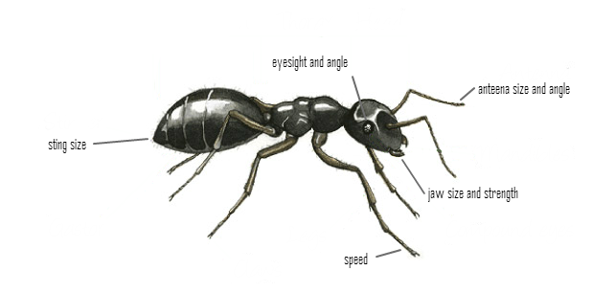**Reproduction rate** – The chance of a new ant being born.

A species is a specific set of values for an ants characteristics. All ants belong to a single species in the simulation. A species values for characteristics can be edited through the interface (see layout) however the characteristics of a species have a chance of mutating in the simulation whenever a queen ant is born. If the species does not mutate, the queen will go on to create a nest expanding the spread of the species. However, if a mutation does occur a new species is created and all ants born from the nest which the queen founds will inherit the mutated characteristic. This can be either an advantage or disadvantage on the efficiency of the ant.

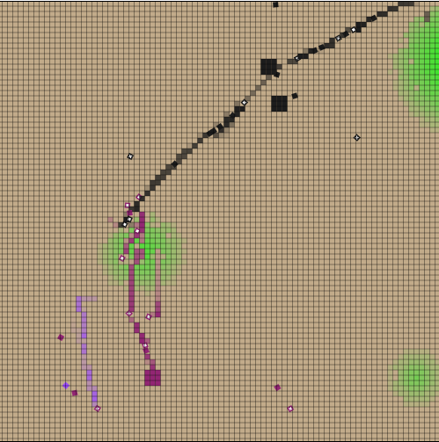

Three different species shown, including 3 nests (two of the same species)

# Installation

There is no need to install the simulation, it can be run via visiting it in a web browser.

## System Requirements

|  |  |  |
| --- | --- | --- |
| **Web browser** | **Minimum required** | **Recommended version** |
| Chrome | 4 | 30 or higher |
| Firefox | 4 | 25 or higher |
| Internet Explorer | 10 | 11 or higher |
| Safari | 3.1 | 7.0 or higher |

# Layout

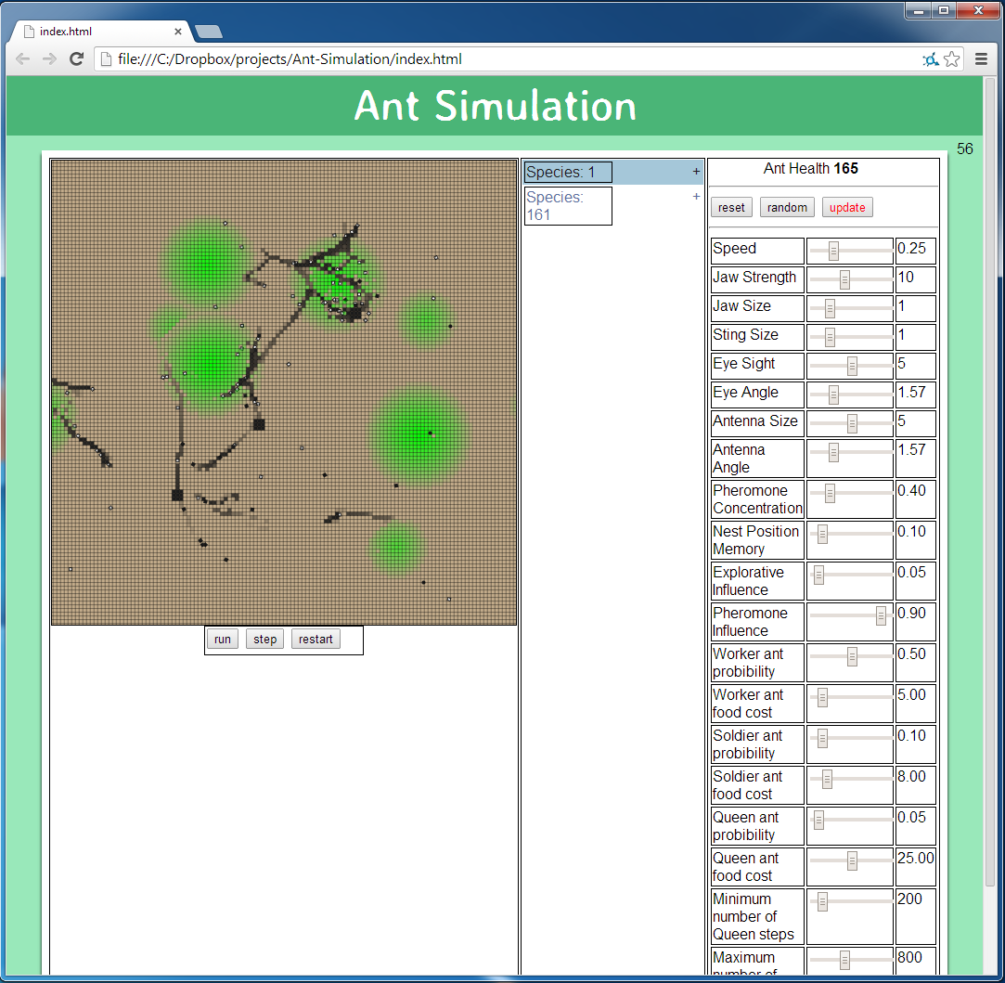The page is split into three sections, the simulation panel, data panel and configuration panel.

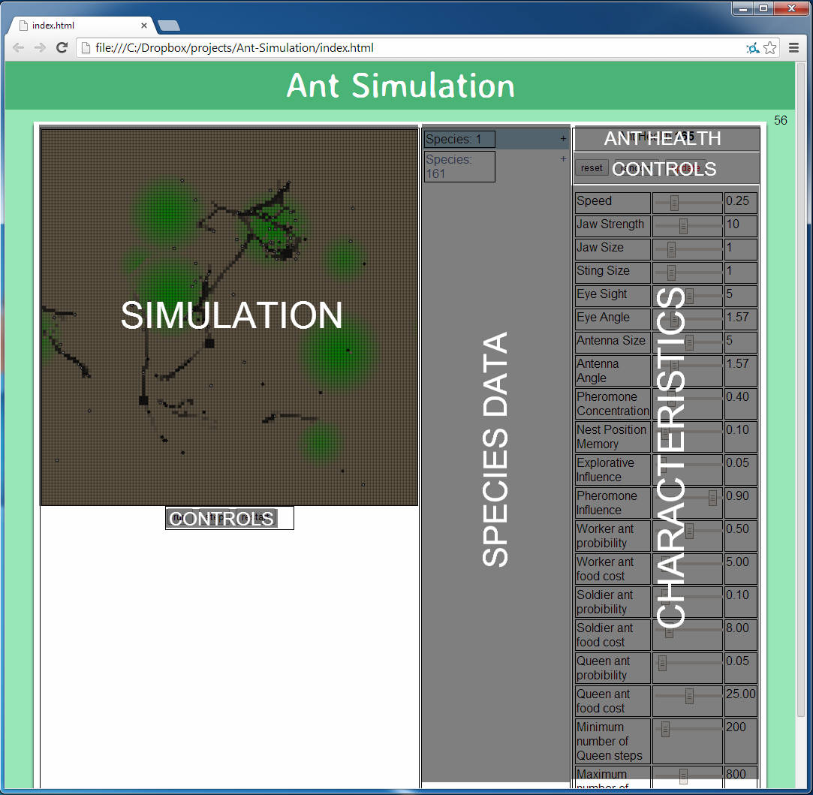

## Simulation panel

Contains the simulation itself, as well as three buttons which are used to control the simulation:

* C:\Dropbox\projects\Ant-Simulation\assests\User Manual\Uses\Time controls.PNG**Run/Pause** – Toggle to start and stop the simulation
* **Tick** – Move a single step forward in the simulation. Useful if you want to closely observe the ant’s behaviour.
* **Restart** – Reset the simulation to default settings.

## Data panel

The data panel contains information about all of the species currently in the simulation. As new species are created i.e. mutations occur, they are added to the data panel. Each species can be expanded by clicking on the +/- button to show more information about that species such as the number of ants and nests and the amount of food in the nests. The colour of the species text is the same colour of the species which it represents. You can select a species by clicking on the species name, this will move the simulation to centre on the first nest in the species, it will also display the species characteristics in the configuration panel. (Note: the numbers next to the species id the species ID, it does not represent any information about the species i.e. Species: 17.)

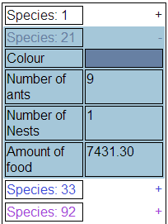

Species 21 is expanded and selected

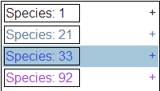

The specie panel, all species are contracted. Species: 33 is selected

## Configuration panel

C:\Dropbox\projects\Ant-Simulation\assests\User Manual\Uses\configuration panel controls.PNGThe configuration panel contains the characteristics of the selected species. By changing the inputs, characteristics values can be altered. Once a modification to a characteristic is made the ants health is updated to reflect this change. The buttons at the top control the inputs:

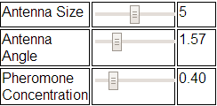

A sample of characteristics

* **Reset** – Resets all characteristics to their default values.
* **Random** – Replaces all characteristics with random values.
* **Update** – Updates the selected species to reflect the changes made in the characteristics panel.

# Use

How to use the simulation

## Tips and shortcuts

|  |  |
| --- | --- |
| **Control** | **Action** |
| Arrow keys | Pan around the map |
| Mouse click and drag | Pan around the map |
| + and - keys | Zoom into and out of the map |
| Mouse scroll | Zoom into and out of the map |
| Space key | Pause/Play the simulation |
| R key | Restart the simulation |
| S key | Do a single step in the simulation |

* 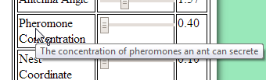Hovering over a characteristic will display a description of what it does.
* Clicking on a species will centre the map on the first nest in that species.
* C:\Dropbox\projects\Ant-Simulation\assests\User Manual\Uses\configuration panel controls (update).PNGThe update button will turn red if there is a change to the configuration of a species characteristics which is not reflected in the simulation.

# Features

# Errors